Creating a Custom Media Consent Report
Before You Start
Identify which records should be included in the Media Consent report.
(examples: members of a specific club, activity, grade, project, event,etc.)
- Click on the Custom Reports tab in the navigation pane.  - Click on the folder title in which you want to add your new report.  - Click Add Report to create a new report in the selected folder. |  | 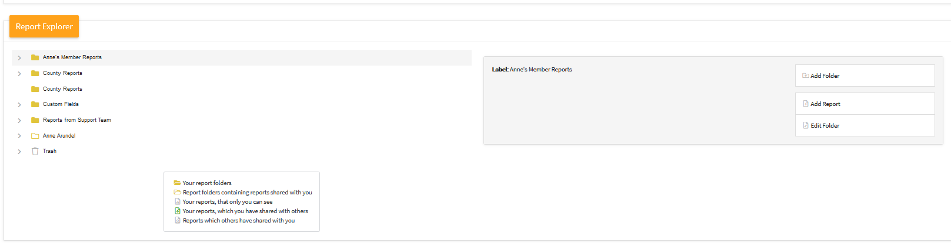
- Enter the name of your report.  - Enter a description of the report.  - Enter the name of the Excel Worksheet title.  - Click the Add button. |  | 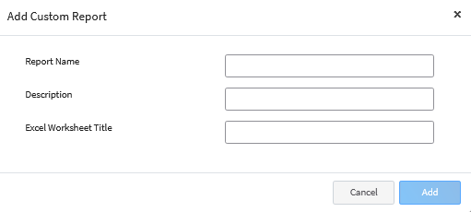
- In the Report Detail section, you may edit the name and description of your report.  (example: County Riding Club Media Consents) |  | 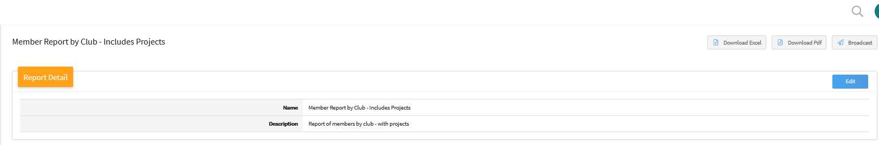
- The Target Data area allows you to set the program year for the report data.  - The Hierarchy drop-down menu allows you choose the county or area of the hierarchy for the report (within the Manager’s assigned hierarchy areas). |  | 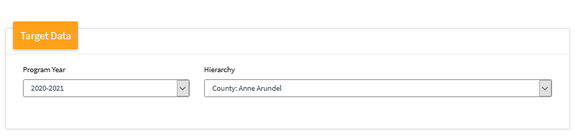
- Click Edit on the Report Columns category to begin selecting the columns (fields) to be included on the report.  - Click on the Column Category to view the available fields to include in the report. You may select columns from as many column categories as needed.  - Click on the field name and click the right arrow to add it to the report.  - Repeat steps 12 – 14 for each field you need to add to the report.  - Click Save. |  | 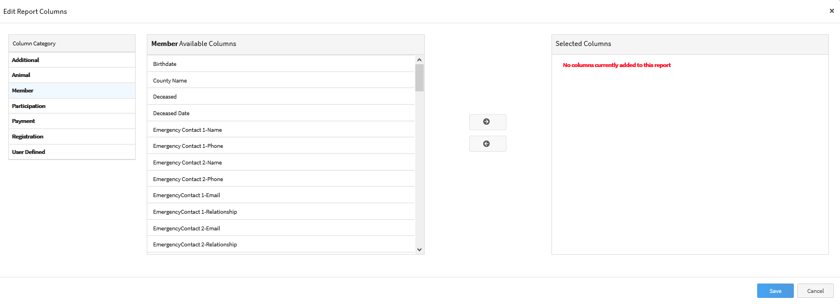  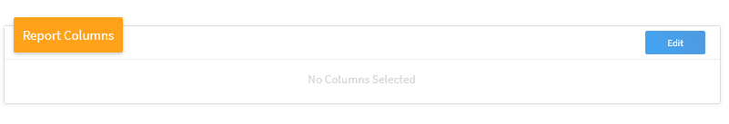
Example of fields to include in a Media Consent Report:  Member: Last, First  Participation: Enrollment Program Year  Participation: Enrollment Role  Participation: Enrollment Status  Participation: Enrollment County  Participation: Enrollment Consent Title  Participation: Enrollment Consent Status  Participation: Enrollment Consent Date  Participation: Enrollment Consent Member Signature  Participation: Enrollment Consent Parent/Signature  Participation: Enrollment Consent Manager Signature |  | 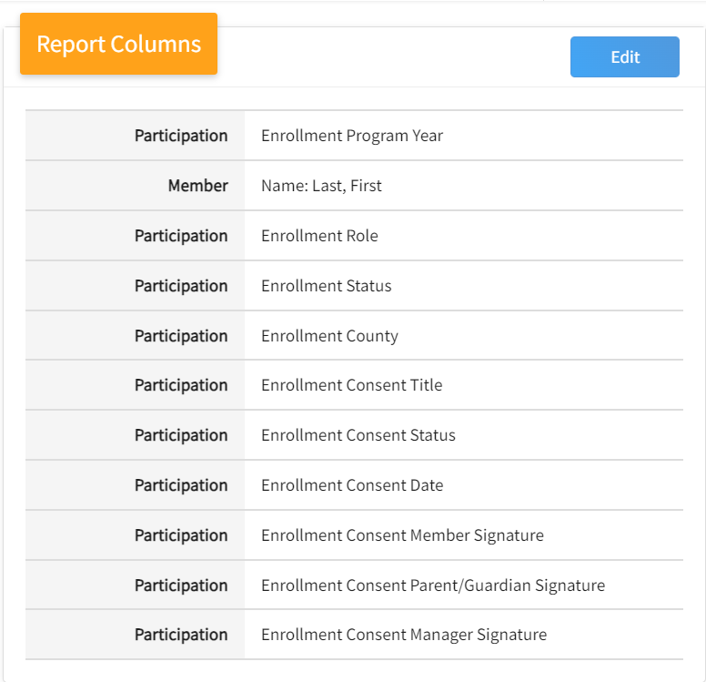
Standard Filters  - Click Edit next to Standard Filters section to add filters for pulling your Media Consents.  Example: filter by a specific club, enrollment role, flagged members, school grade, projects, etc.  NOTE: A common filter used for pulling Media Consents is the Units/Clubs. |  | 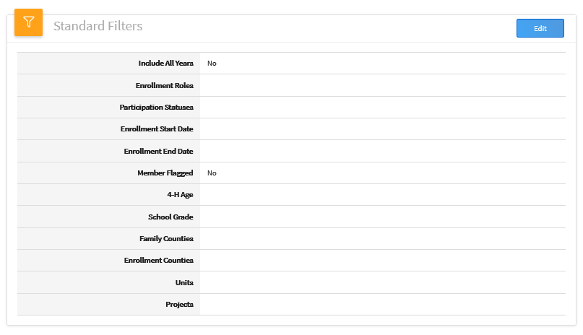
Creating Additional Filters  NOTE: The Custom Filters section can be used to create filters not covered in the Standard Filters section.  - Add additional filters by clicking Edit next to the Custom Filters section.  - Click the Add group button.  - Click the Add filter button.  - Select the data field you would like to filter the report on.  In this case you would select “Enrollment Consent Title”  - Select the operator. Depending on the data field you are filtering on, the operator choices may change.  In this case you would select “Equal Available Options”  - Select from the available options in the drop-down to filter for.  In this case you would filter for the “Youth Media Release”  - Once you have entered your custom filter options, click Save.  NOTE: Examples of additional Custom Filters to use for Media Consents would be Activity, Group or Event Names. | 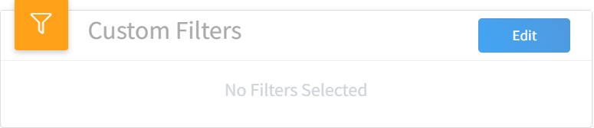  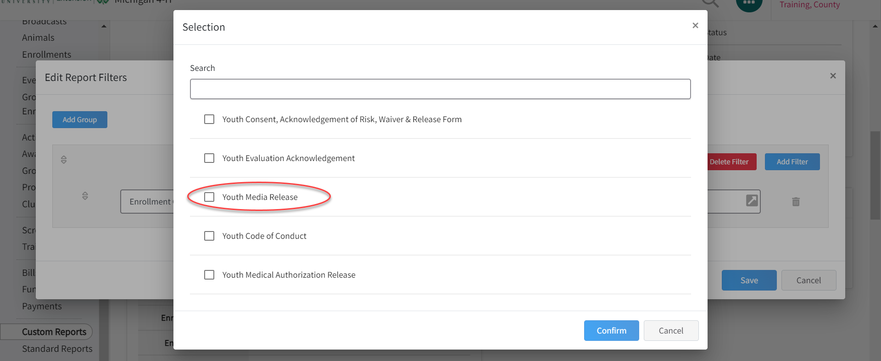  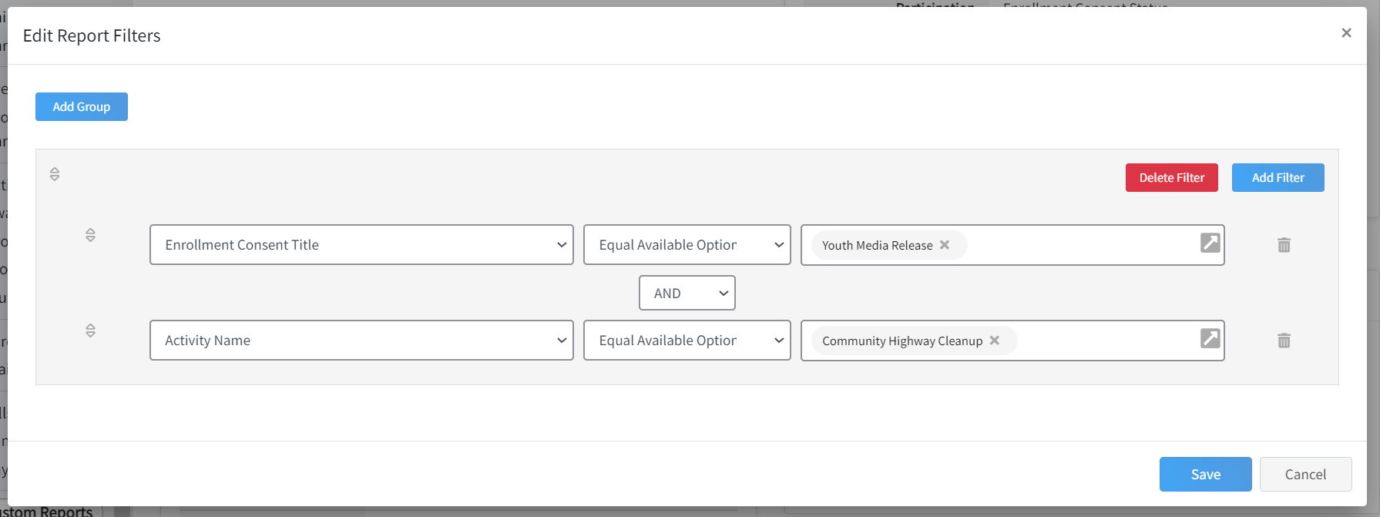  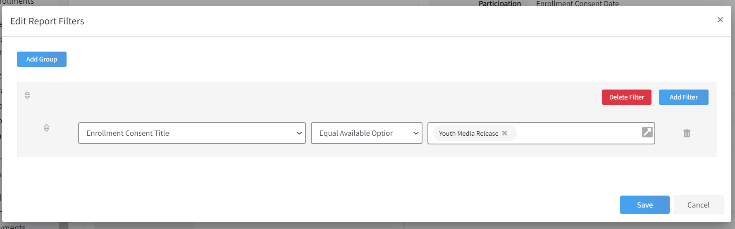  Example:  A custom filter was added for the  “Enrollment Consent Title” equals  “Youth Media Release”  And  “Activity Name” equals “Community Highway Cleanup”  This will pull the media consents for anyone who was added to the activity titled “Community Highway Cleanup.”
- Scroll down to the Preview section and click on the Refresh tab. | 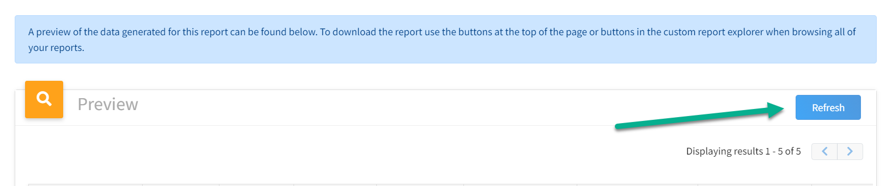
NOTE: Always click on the Refresh tab to update your results with any changes that occur to enrollments.
Enrollment Consent Status Results  - Return to the top of the screen to select to download an Excel file.  - Sort Column “G – Enrollment Consent Status” to identify any youth who have “Disagree” as the consent status. | 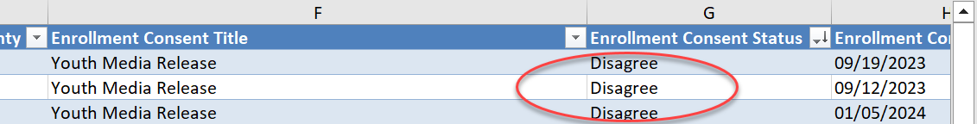  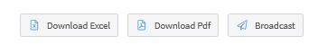
NOTE: The Custom Media Consent Report can be edited at any time. Changes can be made to the standard or custom filters, or edits to the columns and fields that were included in the report. Select the “Edit Report” option. Once in edit mode, you may change your filters to include other consents, clubs, events, activites, etc.
Remember: After saving changes, click on Refresh option on the report prview to display new results.

